1. Paths program can take

P1 - 1,2,3,4,5,6,7,8,10,11,23,24,25,26

P2- 1,2,3,4,5,6,7,8,9,12,13,14,23,24,25,26

P3 – 1,2,3,4,5,6,7,8,9,12,13,15,16,23,24,25,26

P4 – 1,2,3,4,5,6,7,8,9,12,13,17,18,19,20,21,22,23,24,25,26

1. Diagram

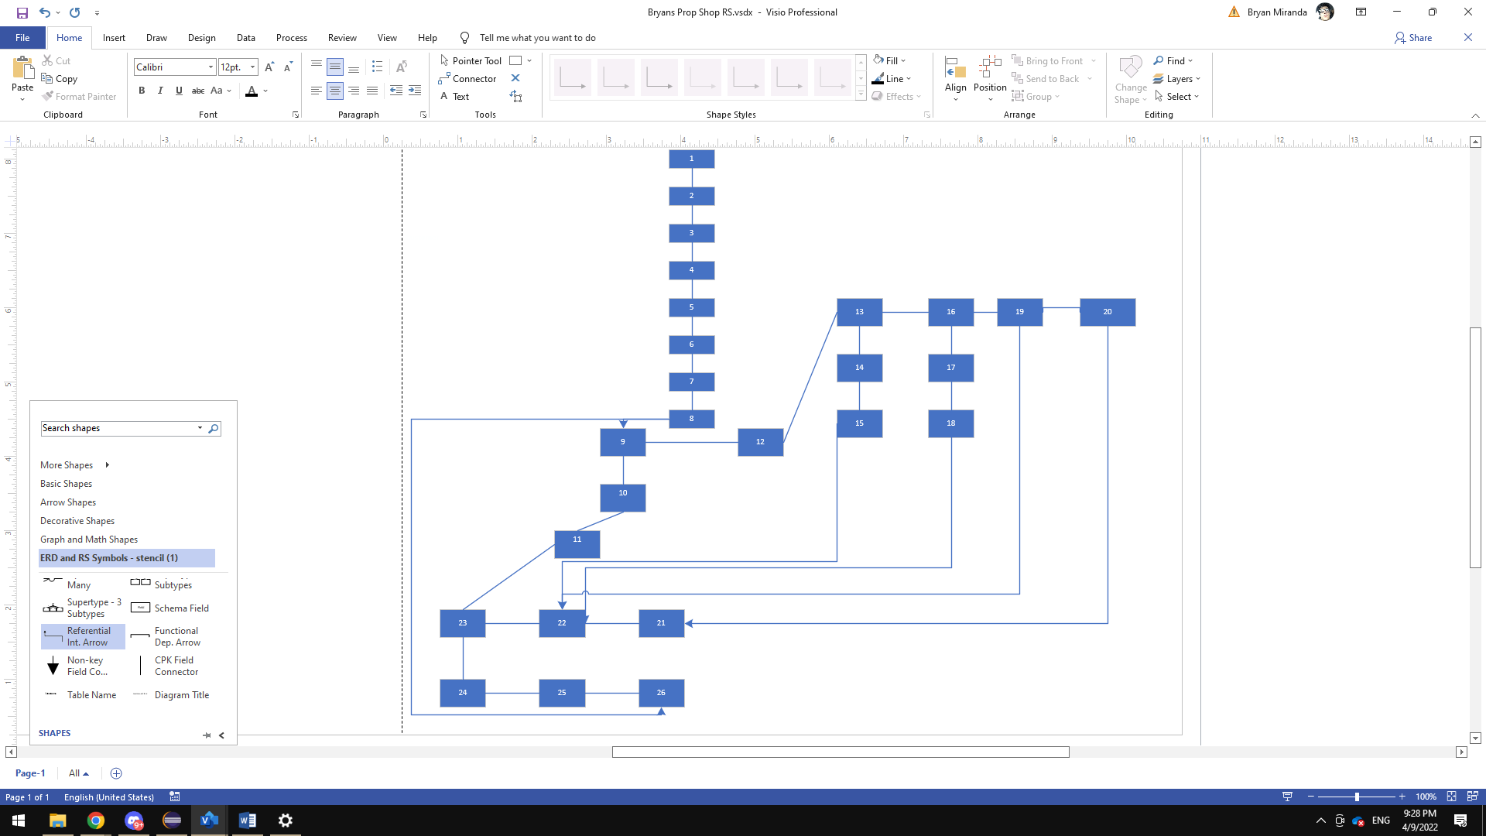

1. Testing different set of inputs and boundary values –

|  |  |
| --- | --- |
| **Test CaseID** | TC1 |
| **Program** | Power.Java with Eclipse |
| **Purpose of Test Case** | To analyze errors that can occur in the calculated output but on the variable |
| **Structural Test Type** | Structural Testing |
| **Path Being Tested** | Path 4 |
| **Pre-Conditions** | 34,50,70 |
| **Inputs** | Successfully gives respected outputs Fail , Pass,pass |
| **Expected Outputs** | Output gets printed |
| **All statements in the above path covered as expected?** | Yes |
| **Expected Conditions** | Output displays results |
| **Post Conditions** |  |
| **Execution History** | Bryan Miranda : Result : Output matches expected output 04/09/2022 |

|  |  |
| --- | --- |
| **Test CaseID** | TC2 |
| **Program** | Power.Java with Eclipse |
| **Purpose of Test Case** | To analyze errors that can occur in the calculated output but on the variable |
| **Structural Test Type** | Structural Testing |
| **Path Being Tested** | Path 1 |
| **Pre-Conditions** | 34.99 |
| **Inputs** | Successfully gives respected outputs Fail |
| **Expected Outputs** | Output gets printed |
| **All statements in the above path covered as expected?** | Yes |
| **Expected Conditions** | Output displays results |
| **Post Conditions** | Output gives an error doesn’t let you get passed 1 input |
| **Execution History** | Bryan Miranda: Result: Doesn’t matched expected output. 04/09/2022 |

|  |  |
| --- | --- |
| **Test CaseID** | TC3 |
| **Program** | Power.Java with Eclipse |
| **Purpose of Test Case** | To analyze errors that can occur in the calculated output but on the variable |
| **Structural Test Type** | Structural Testing |
| **Path Being Tested** | Path 2 |
| **Pre-Conditions** | 34,55.5 |
| **Inputs** | Successfully gives respected outputs Fail ,Pass |
| **Expected Outputs** | Output gets printed |
| **All statements in the above path covered as expected?** | Yes |
| **Expected Conditions** | Output displays results |
| **Post Conditions** | Output gives an error doesn’t let you get passed 2nd input |
| **Execution History** | Bryan Miranda: Result: Doesn’t matched expected output. 04/09/2022 |

|  |  |
| --- | --- |
| **Test CaseID** | TC4 |
| **Program** | Power.Java with Eclipse |
| **Purpose of Test Case** | To analyze errors that can occur in the calculated output but on the variable |
| **Structural Test Type** | Structural Testing |
| **Path Being Tested** | Path 4 |
| **Pre-Conditions** | 34,55,110 |
| **Inputs** | Successfully gives respected outputs Fail ,Pass,Pass |
| **Expected Outputs** | Output gets printed |
| **All statements in the above path covered as expected?** | Yes |
| **Expected Conditions** | Output displays results |
| **Post Conditions** | Output on 3rd input falls back to securing a C versus an A |
| **Execution History** | Bryan Miranda: Result: Doesn’t matched expected output. 04/09/2022 |

|  |  |
| --- | --- |
| **Test CaseID** | TC5 |
| **Program** | Power.Java with Eclipse |
| **Purpose of Test Case** | To analyze errors that can occur in the calculated output but on the variable |
| **Structural Test Type** | Structural Testing |
| **Path Being Tested** | Path 4 |
| **Pre-Conditions** | 60,70,90 |
| **Inputs** | Successfully gives respected outputs Pass , Pass, Pass |
| **Expected Outputs** | Output gets printed |
| **All statements in the above path covered as expected?** | Yes |
| **Expected Conditions** | Output displays results |
| **Post Conditions** | Output Provides all scores Pass C , Pass C , Pass A |
| **Execution History** | Bryan Miranda: Result: Output gives expected output 04/09/2022 |

**DEFECT REPORTING FORM**

**DEFECT ID:** DEFECTTC2

**TITLE:** Input not satisfying for the grade **COMPONENT:** Program java

**REPORTED BY: Bryan Miranda SUBCOMPONENT: Java code**

**REPORTED ON: 04/09/2022 VERSION: N/A**

**PLATFORM: PC RESOLUTION PRIORITY: P2**

**OPERATING SYSTEM: WINDOWS 10 RESOLUTION SEVERITY: S1**

**RELATED TEST CASE IDS:** TC2 **CONSISTENCY: PERIODIC**

**DEFECT SUMMARY:** Adding a decimal for first input gives an error

**STEPS TO REPRODUCE:**

1. **Input 34.99. Error gets displayed**

**COMMENTS: N/A  
ATTACHMENTS:  
1.**

**2.  
For evaluators use only**

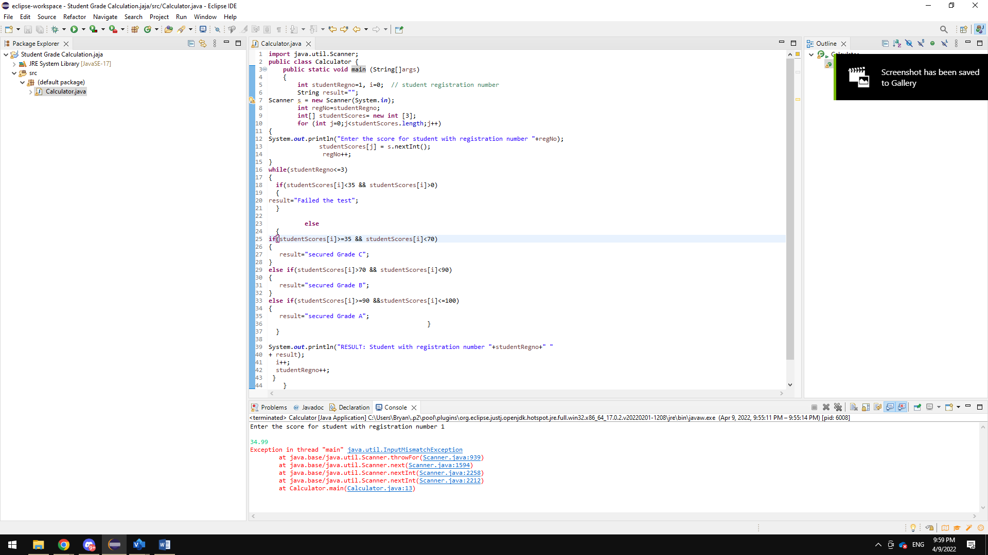

**DEFECT STATUS: _________APPROVED _________ REJECTED  
REASON: ________________________________________________**

**DEFECT REPORTING FORM**

**DEFECT ID:** DEFECTTC3

**TITLE:** Input not satisfying for the grade **COMPONENT:** Program java

**REPORTED BY: Bryan Miranda SUBCOMPONENT: Java code**

**REPORTED ON: 04/09/2022 VERSION: N/A**

**PLATFORM: PC RESOLUTION PRIORITY: P2**

**OPERATING SYSTEM: WINDOWS 10 RESOLUTION SEVERITY: S1**

**RELATED TEST CASE IDS:** TC3 **CONSISTENCY: PERIODIC**

**DEFECT SUMMARY:** Adding a decimal for second input gives and error

**STEPS TO REPRODUCE:**

1. **Input any number for 1st input**
2. **Type in a second decimal for 2nd input**
3. **Error comes back**

**COMMENTS: N/A  
ATTACHMENTS:  
1.**

**2.  
For evaluators use only**

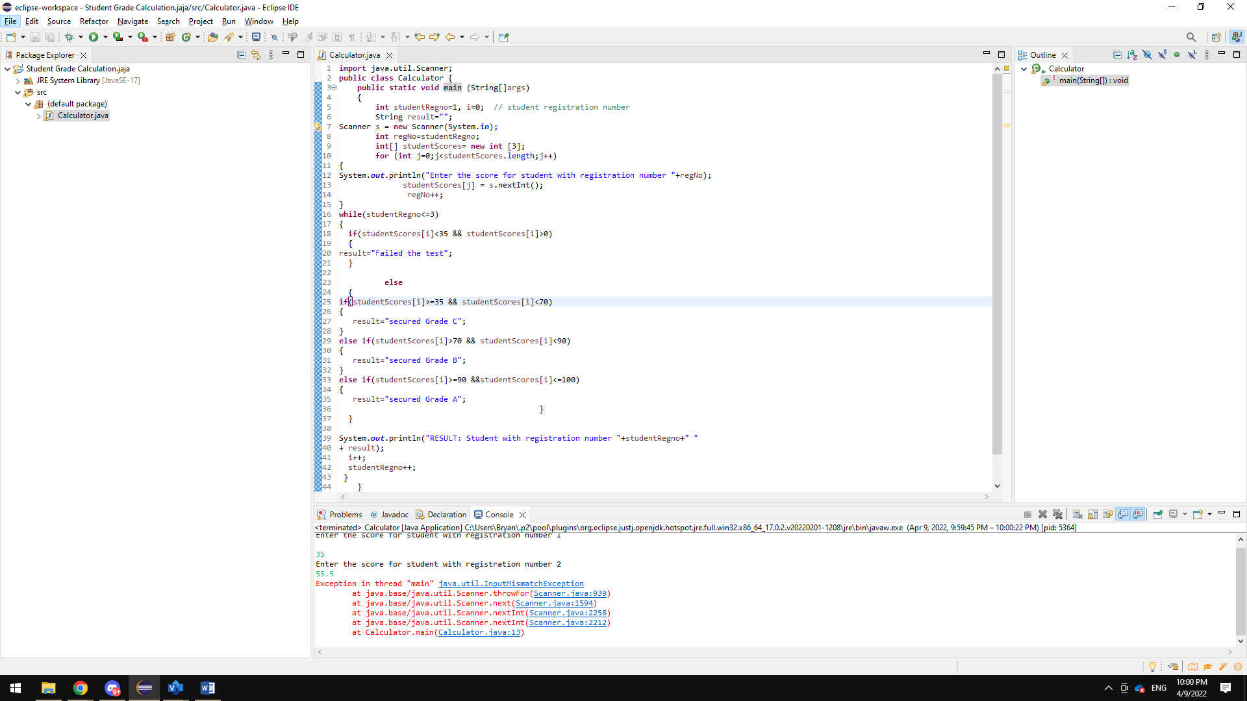

**DEFECT STATUS: _________APPROVED _________ REJECTED  
REASON: ________________________________________________**

**DEFECT REPORTING FORM**

**DEFECT ID:** DEFECTTC4

**TITLE:** Input not satisfying for the grade output **COMPONENT:** Program java

**REPORTED BY: Bryan Miranda SUBCOMPONENT: Java code**

**REPORTED ON: 04/09/2022 VERSION: N/A**

**PLATFORM: PC RESOLUTION PRIORITY: P2**

**OPERATING SYSTEM: WINDOWS 10 RESOLUTION SEVERITY: S1**

**RELATED TEST CASE IDS:** TC4 **CONSISTENCY: PERIODIC**

**DEFECT SUMMARY:** Adding a high number for a 3rd input gives back a different grade when number >100

**STEPS TO REPRODUCE:**

1. **Input 1st number**
2. **Input 2nd number**
3. **Input 3rd number**
4. **All grades are received but 3rd input comes back as a C when range is >100**

**COMMENTS: N/A  
ATTACHMENTS:  
1.**

**2.  
For evaluators use only**

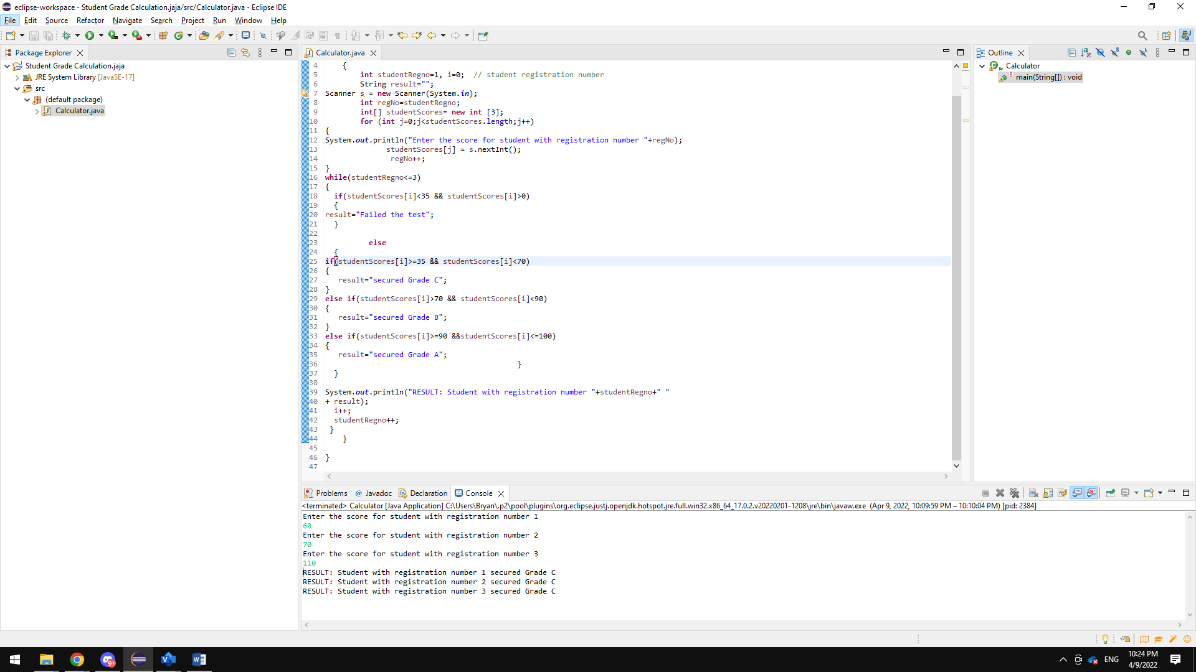

**DEFECT STATUS: _________APPROVED _________ REJECTED  
REASON: ________________________________________________**